Date – 09-09-2021
Activity 1 : To perform operations on data

Data sets used : Products, Transactions

Steps:
- Expand the Samples repository in the Repository panel.
- Next, expand the data folder within the samples repository to retrieve the Products and Transactions data.
- Drag the Products data and the Transactions data from the Samples - Data folder into the Process panel.
- Search for the Join operator in the search box at the top of the Operator panel. Drag Join into the Process panel.
- Connect the output port of Retrieve Products to an input port of Join (it doesn't matter which one).
- Connect Retrieve Transactions to the other Join input port.
- Click on Join to select it. In the Parameters panel find the key attributes field.
- Click Edit List. Select Product ID for the left and right key attributes. Then, click Apply.
- Drag the Aggregate operator into the process. Connect it to the output of Join.
- Click Aggregate to select. Make the following changes in the Parameters panel:
- Click on aggregation attributes.
- Select Customer ID in the left box and set function to count in the right box.
- Stay in this dialog and add another entry Product Name with function set to mode. Click Apply.
- Click on group by attributes. Then, select the Product ID by moving it to the right. Click Apply.
- Connect Aggregate to the result port on the right.
Press Run to execute the process.

Statistics
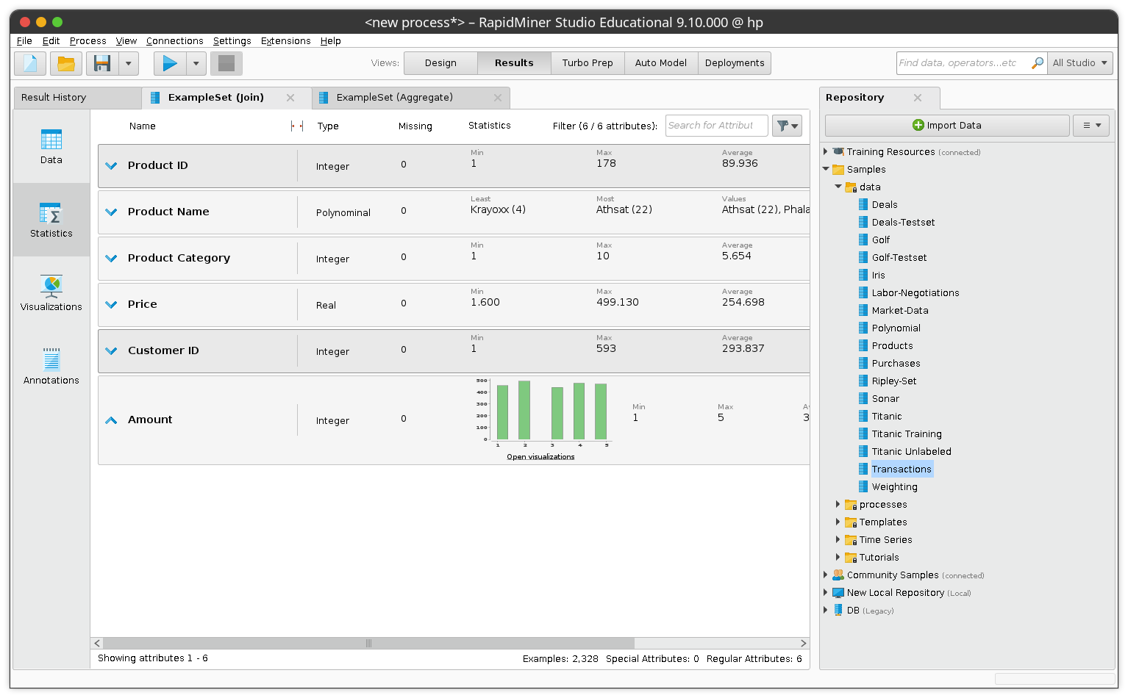

Visualization

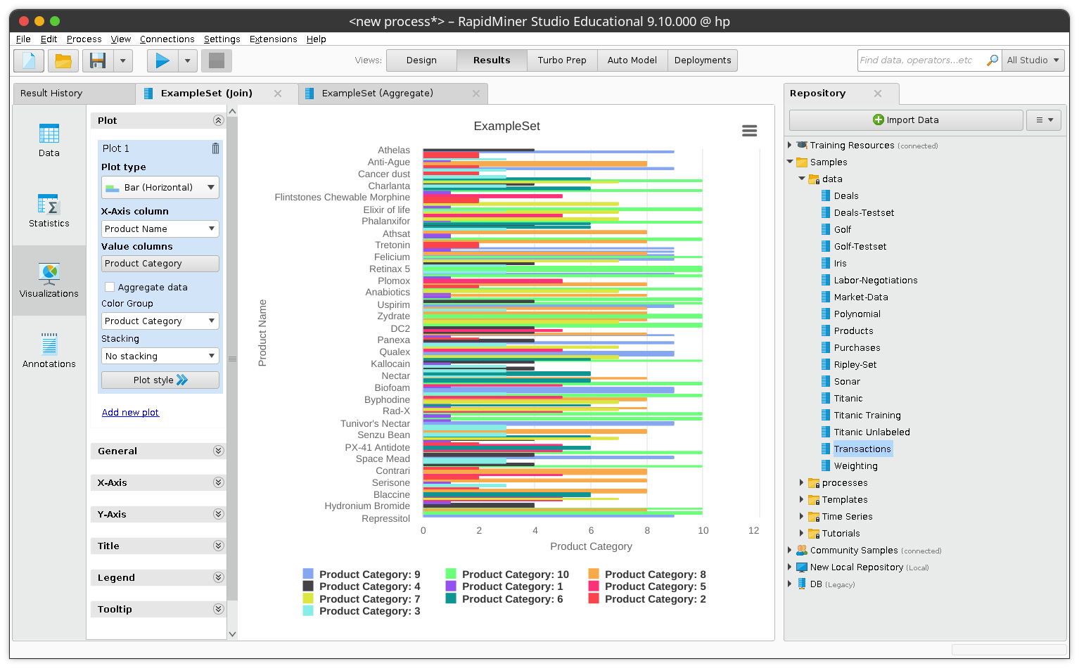

Interpretation
In this activity, I took two different datasets of Products ans Transactions and joined them to view the transactions of a particular product by using the common attribute Product ID.
After joining the results, they were grouped using aggregate.
Date – 09-09-2021
Activity 2 : Working with Attributes

Data sets used : Products, Transactions

Steps:
- Drag the Transactions and Products datasets into the Process.
- Add a Join operator.
- Connect all operators.
- Specify the columns to use in the Parameters for Join. That is, click Edit List, and use Product ID for the left and right key attributes.
- Add the Generate Attributes operator.
- Connect the operator with Join.
- Click Edit List in the Parameters for Generate Attributes to define the new attribute (column). A dialog will pop up.
- In the left column of the dialog, enter Total for the attribute name.
- In the right column, type Amount*Price for the function expression.
- Add the Select Attributes operator to the process and connect it. Make the following changes in Parameters:
- Set attribute filter type to subset. In general, this means that the operator will be applied only to those attributes (columns) you specify. Here this allows you to choose a subset of columns to keep in the data - all other columns will be removed.
- Click Select Attributes.
- In the resulting dialog, select the Customer ID, Product Name, and Total attributes. If the list is empty, you forgot to connect the operator first...
- Run the process.

Statistics
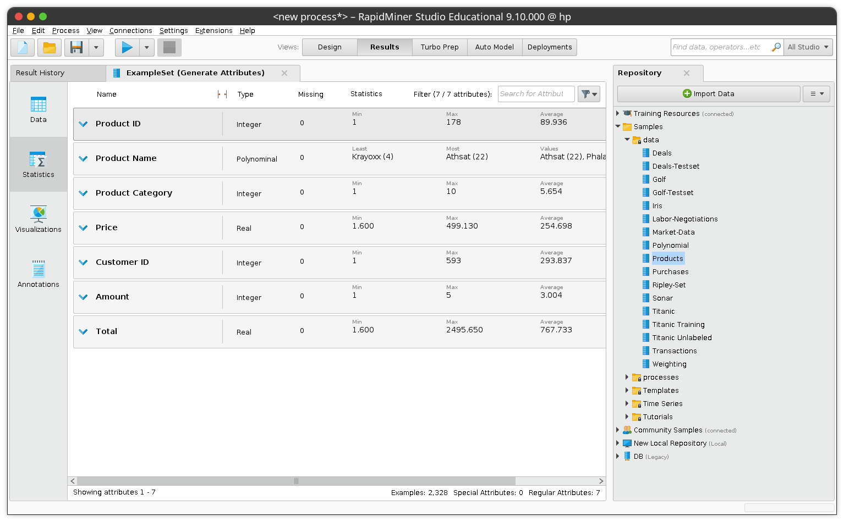
Visualization
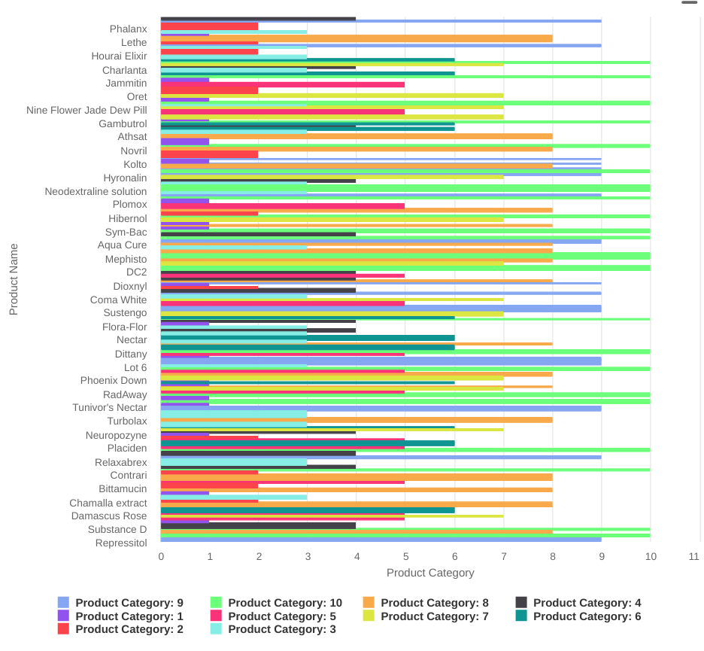

Interpretation
Date – 16-09-2021
Activity 8 : Data Preprocessing

Data sets used : Titanic

Steps:

Statistics
Visualization
Interpretation
Date – 16-09-2021
Activity 8 : Data Preprocessing

Data sets used : Titanic

Steps:

Statistics
Visualization
Interpretation
Date – 16-09-2021
Activity 8 : Data Preprocessing

Data sets used : Titanic

Steps:
- Drag the Titanic data into the process.
- Hover your mouse pointer over the output port and wait for the tooltip to show the meta data.
- Press F3 while the tooltip is shown. It is now transformed into a window and you can scroll down to see the information about all the columns.
- Check for columns with missing values.
- Add a new operator Select Attributes.
- Connect the new operator to the Retrieve operator and the output to the result port "res" on the right.
- In Parameters, change the attribute filter type to Subset and select all attributes but Cabin and Life Boat. This means that those two will be removed by the operator.
- Run the process.
- Click on the Statistics tab and check which attributes with missing values are still left.
- Search for the operator Replace Missing Values and add it to the process. You can drop it on the connection line between Select Attributes and the result port (move the mouse pointer until the connection is highlighted before you drop the new operator). This way you do not need to manually reconnect the operators.
- In the Parameters of this operator, use single for the attribute filter type and select Age for attribute.
- Run the process again and interpret results
- Search for Filter Examples and drop it again on the connection line to the result port. In case you miss the connection, you can of course always manually connect the operator instead.
- Note the link at the bottom of the Parameters panel which shows/hides advanced parameters Click on Show advanced parameters to display all operator parameters.
- New parameters should appear. Set the condition class to no_missing_attributes.
- Run the process again.
- Check the Statistics tab - does it still show missing values for any of the columns?
- Why is it not a good idea to just filter out the examples right away instead of removing attributes and replacing the missings in Age?
- Right-click on Select Attributes and uncheck Enable Operator option. Do the same with Replace Missing Values. What do you expect if you re-run the process now? Try it!
- How many examples are left in the data set now?

Statistics
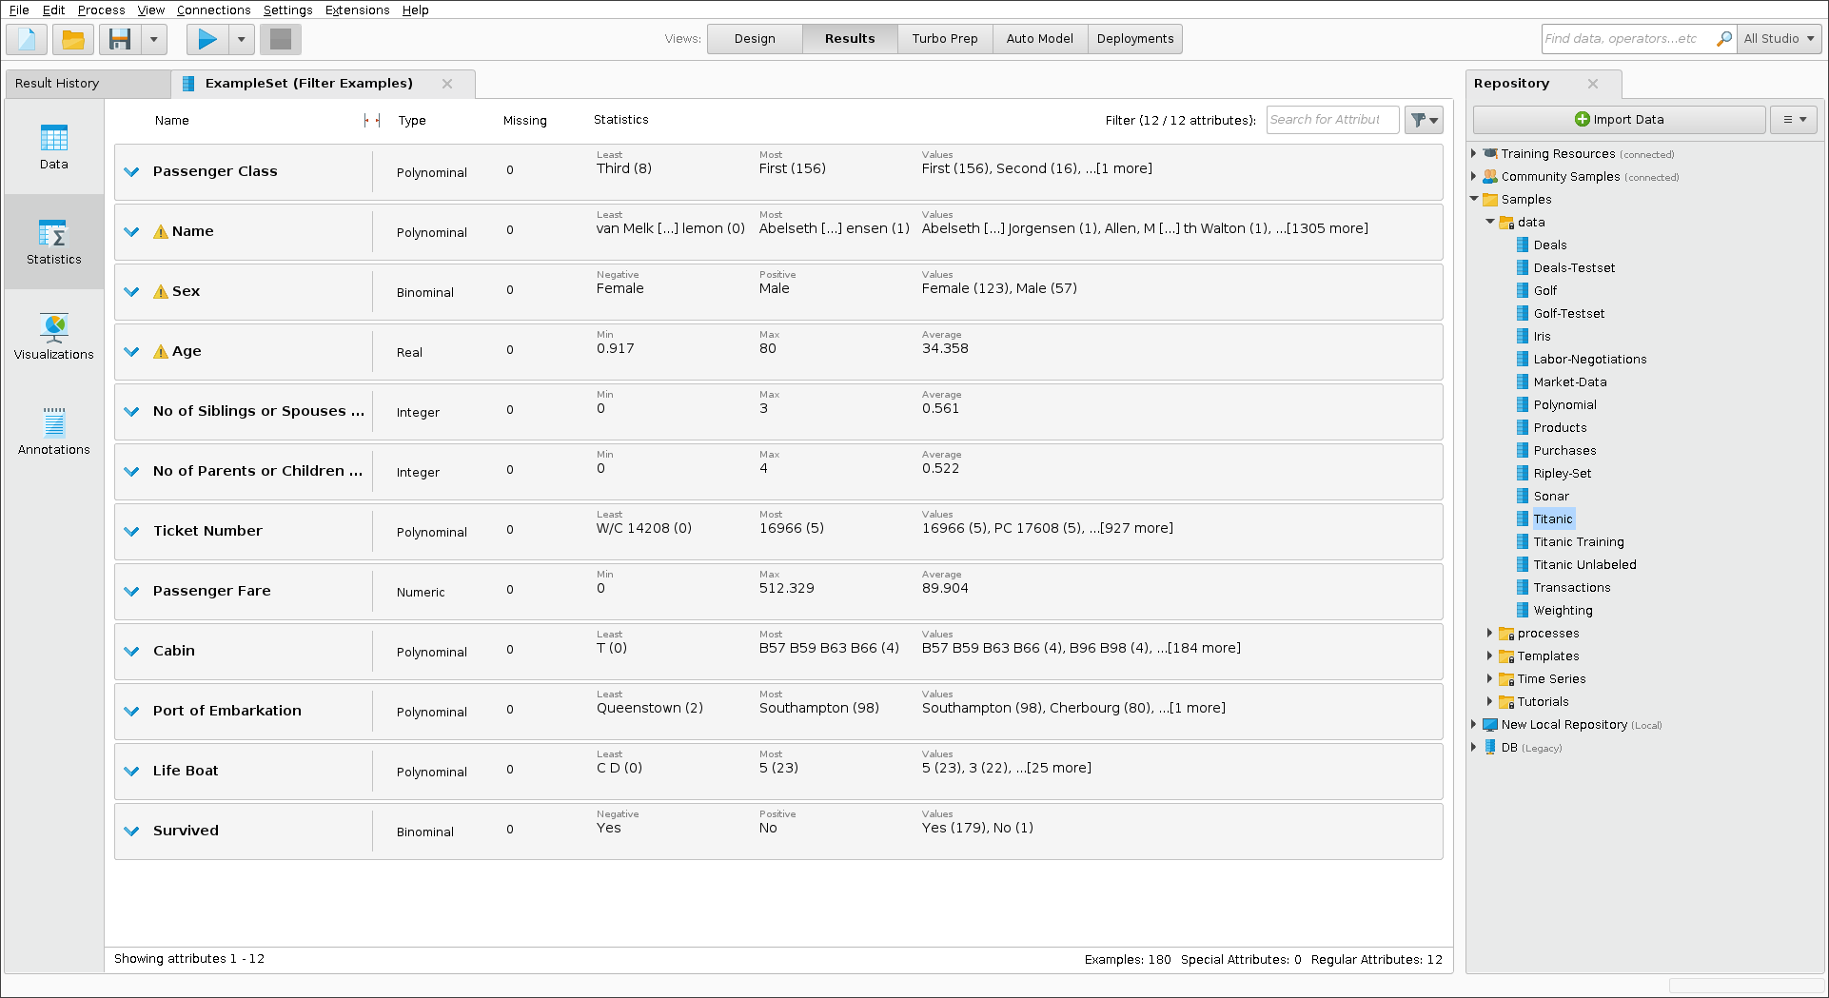
Visualization
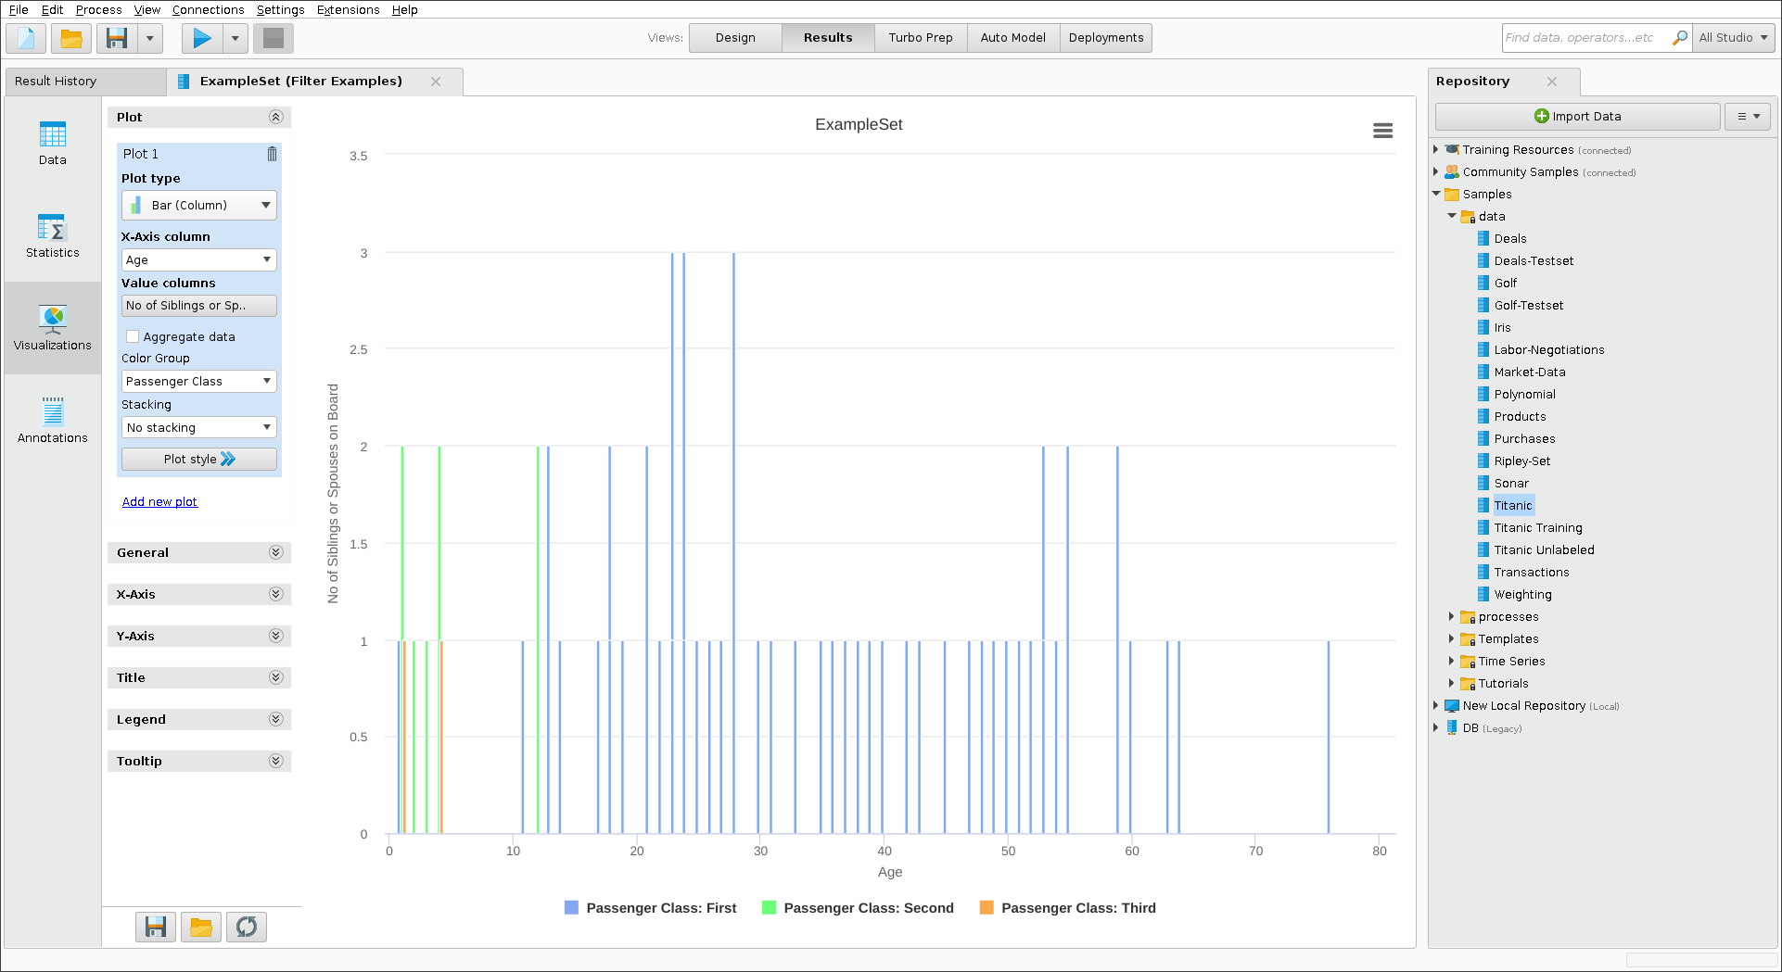
Interpretation

Date – X-09-2021
Activity 9 :

Data sets used : Titanic

Steps:
- Drag the Titanic data into the process.
- Add the operator Select Attributes and connect it.
- Change the Parameters so that you remove Cabin, Life Boat, Name, and Ticket Number .
- Add the operator Normalize and connect it.
- Search for the operator Detect Outlier (Distances), add it, and connect it to Normalize.
- Add Filter Examples to the process and connect it to the previous operator and also to the result port on the right.
- In its Parameters, add a new filter with Outlier, equals, and false as values.
- Run the process.
Statistics
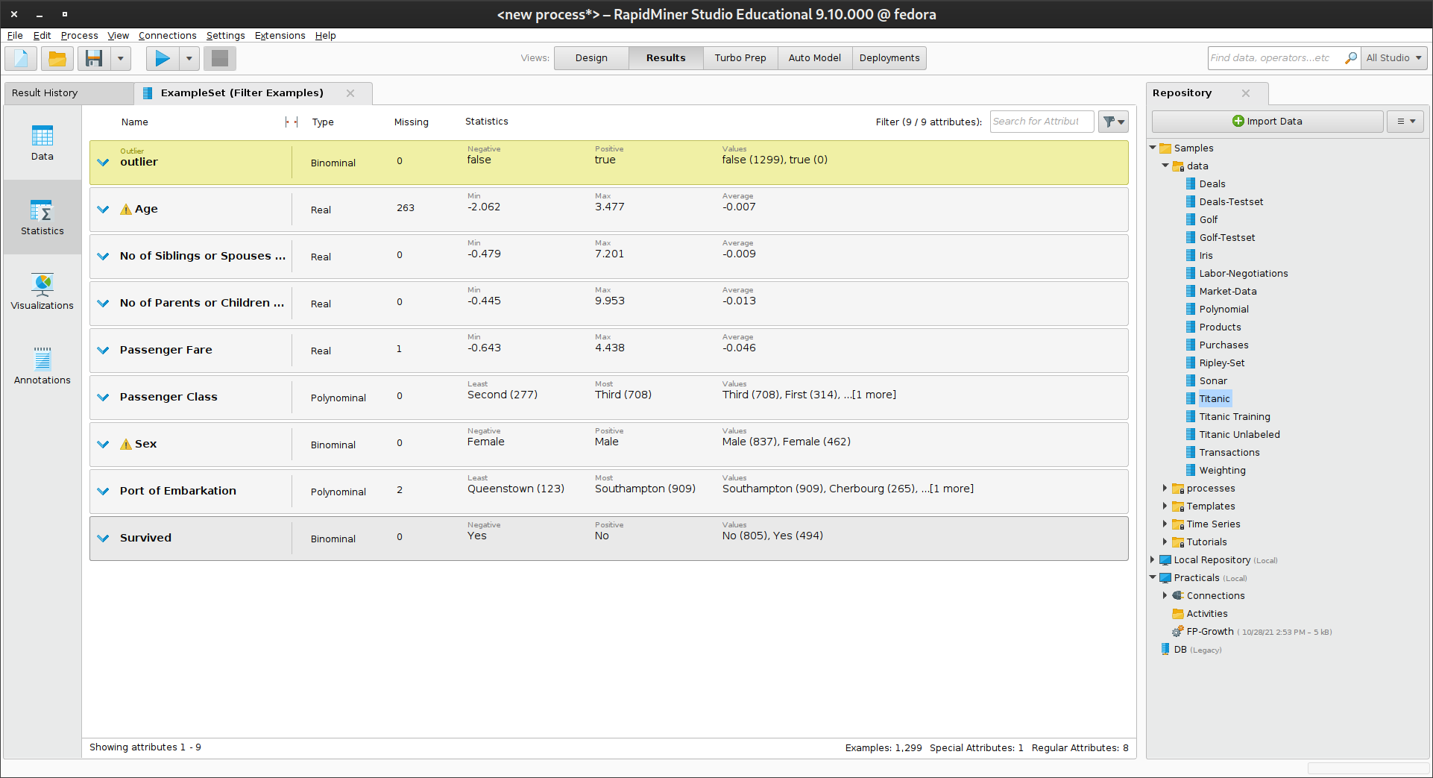
Visualization
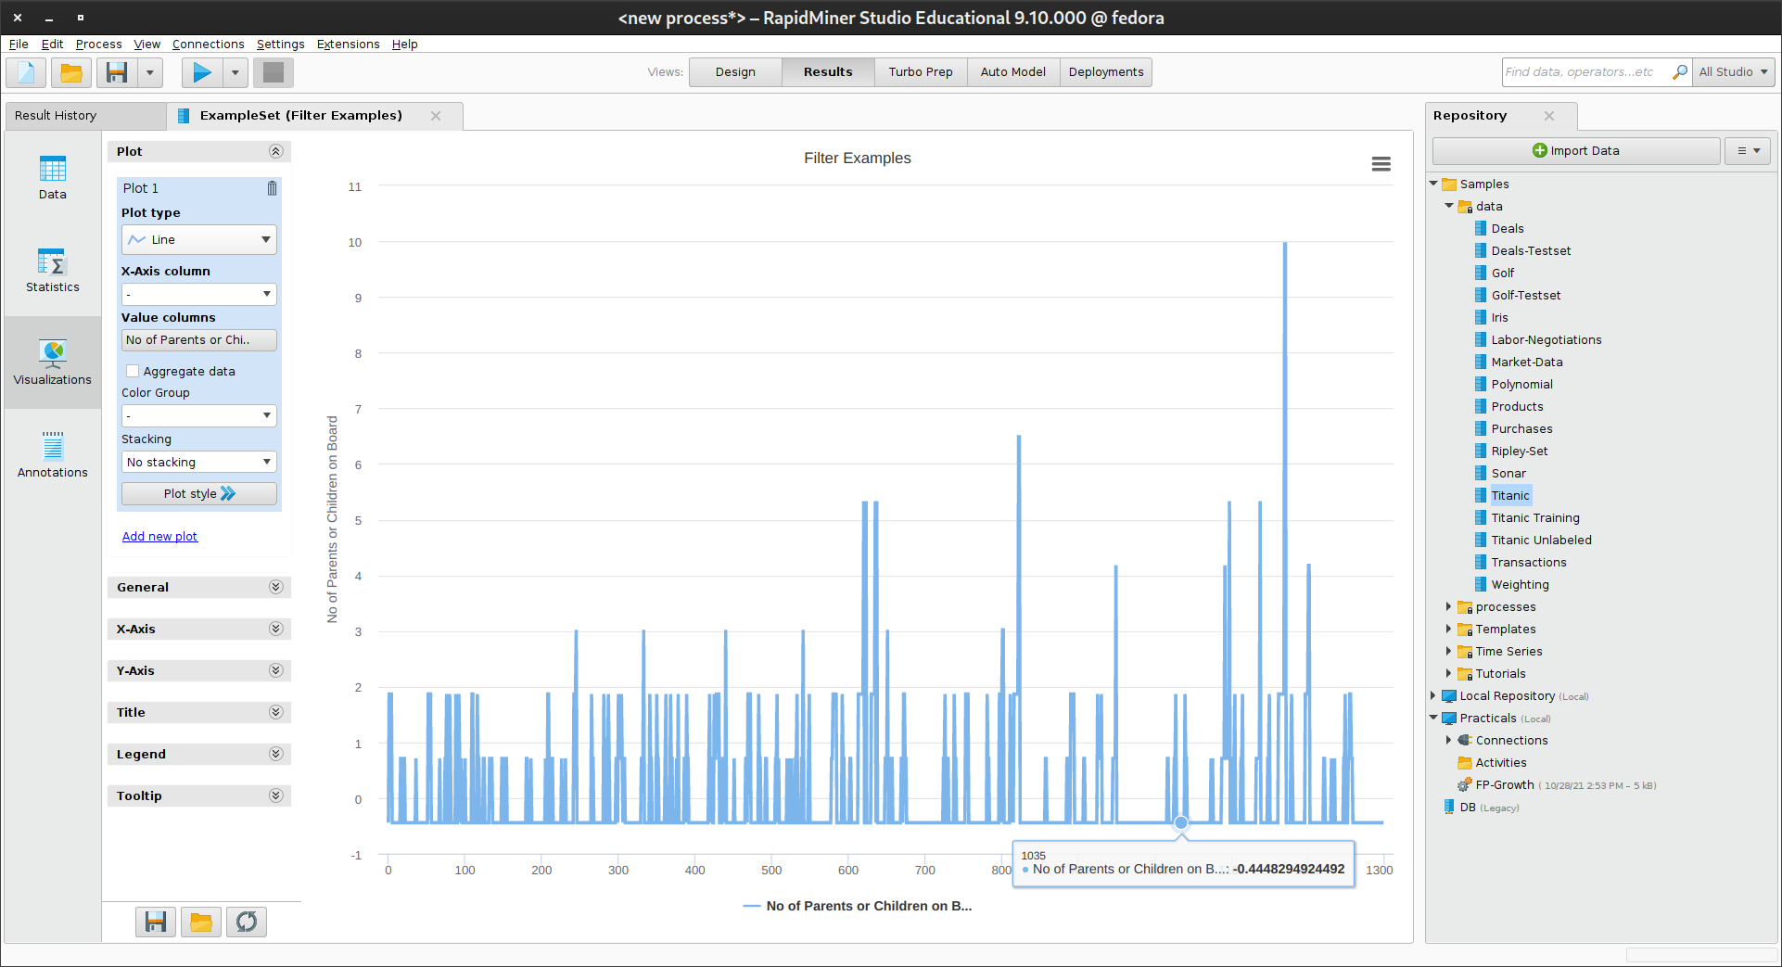
Interpretation
Date – X-09-2021
Activity 10 :

Data sets used : Iris

Steps:
- Drag the Iris data into the process.
- Add the operator Select Attributes and connect it.
- Add the operator Normalize and connect it.
- Search for the operator Detect Outlier (Distances), add it, and connect it to Normalize.
- Add Filter Examples to the process and connect it to the previous operator and also to the result port on the right.
- In its Parameters, add a new filter with Outlier, equals, and false as values.
- Run the process.

Statistics
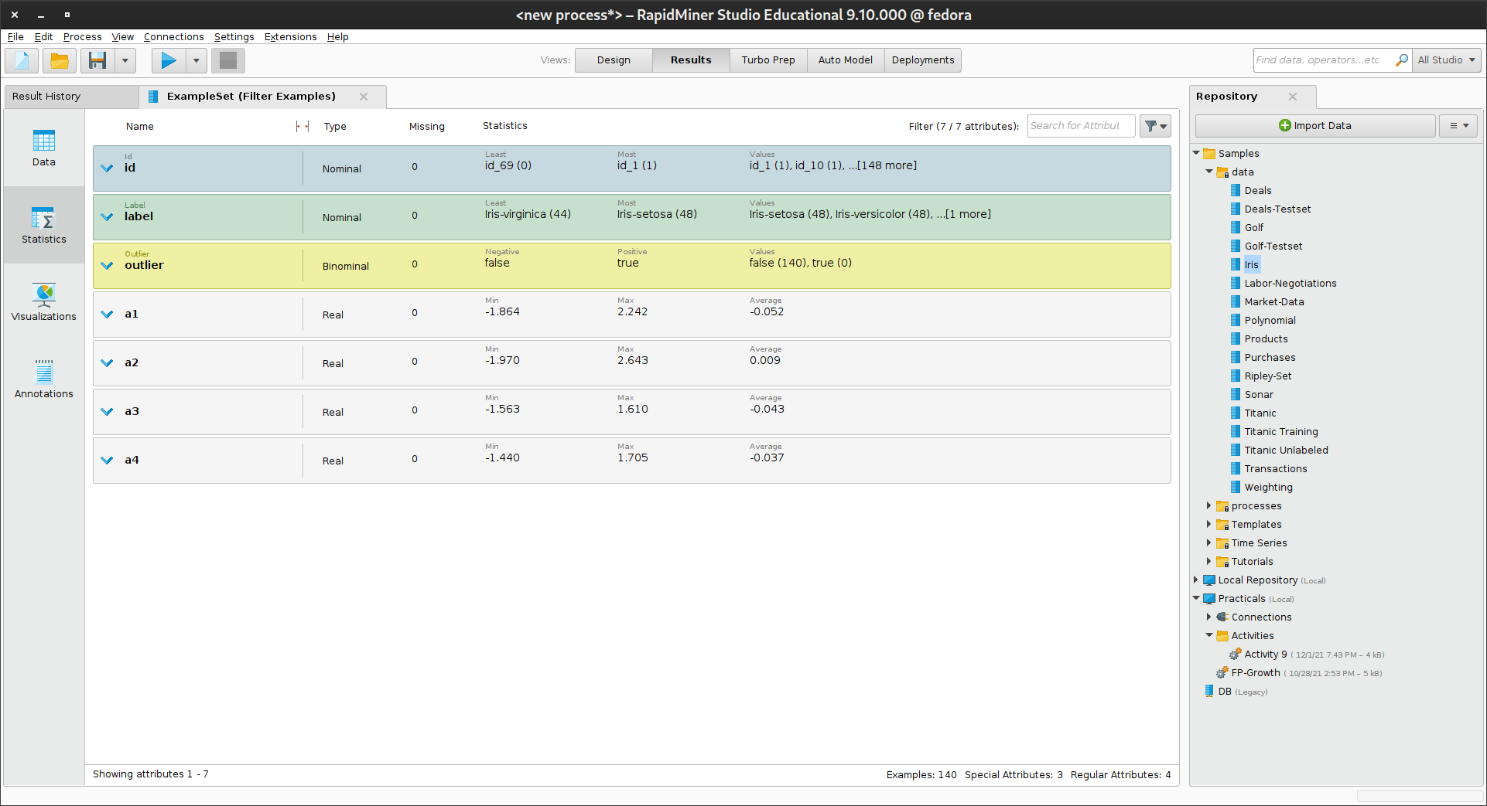
Visualization
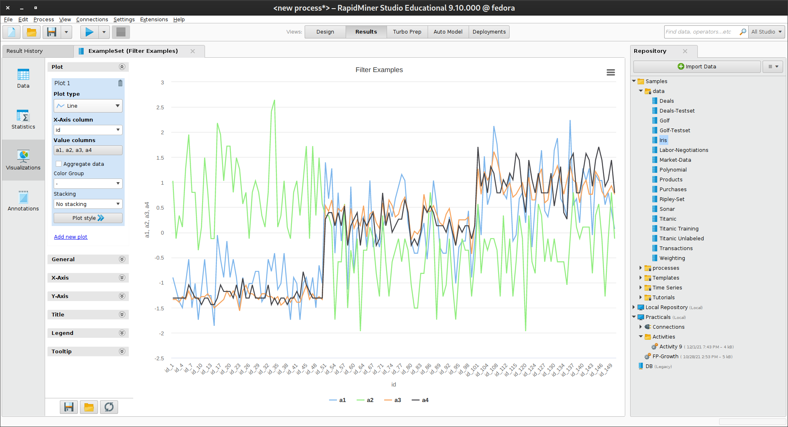

Interpretation
Date – X-X-2021
Activity 11 : Use of Pivot

Data sets used : Titanic

Steps:
- Drag the Titanic data into the process.
- Add the operator Pivot and connect it.
- In its Parameters, add Sex to the group by attributes.
- Select Passenger Class as column grouping attribute.
- Also use Passenger Class with function count as a new entry for aggregation attributes.
- Search for the operator Rename by Replacing, add it, and connect it to Pivot.
- Also connect the operator to the result port on the right.
- Copy count\((.*)\)_(.*) into the replace what parameter field. Make sure that you get all the parentheses right!
- Copy $1 $2 into the replace by parameter.
Statistics
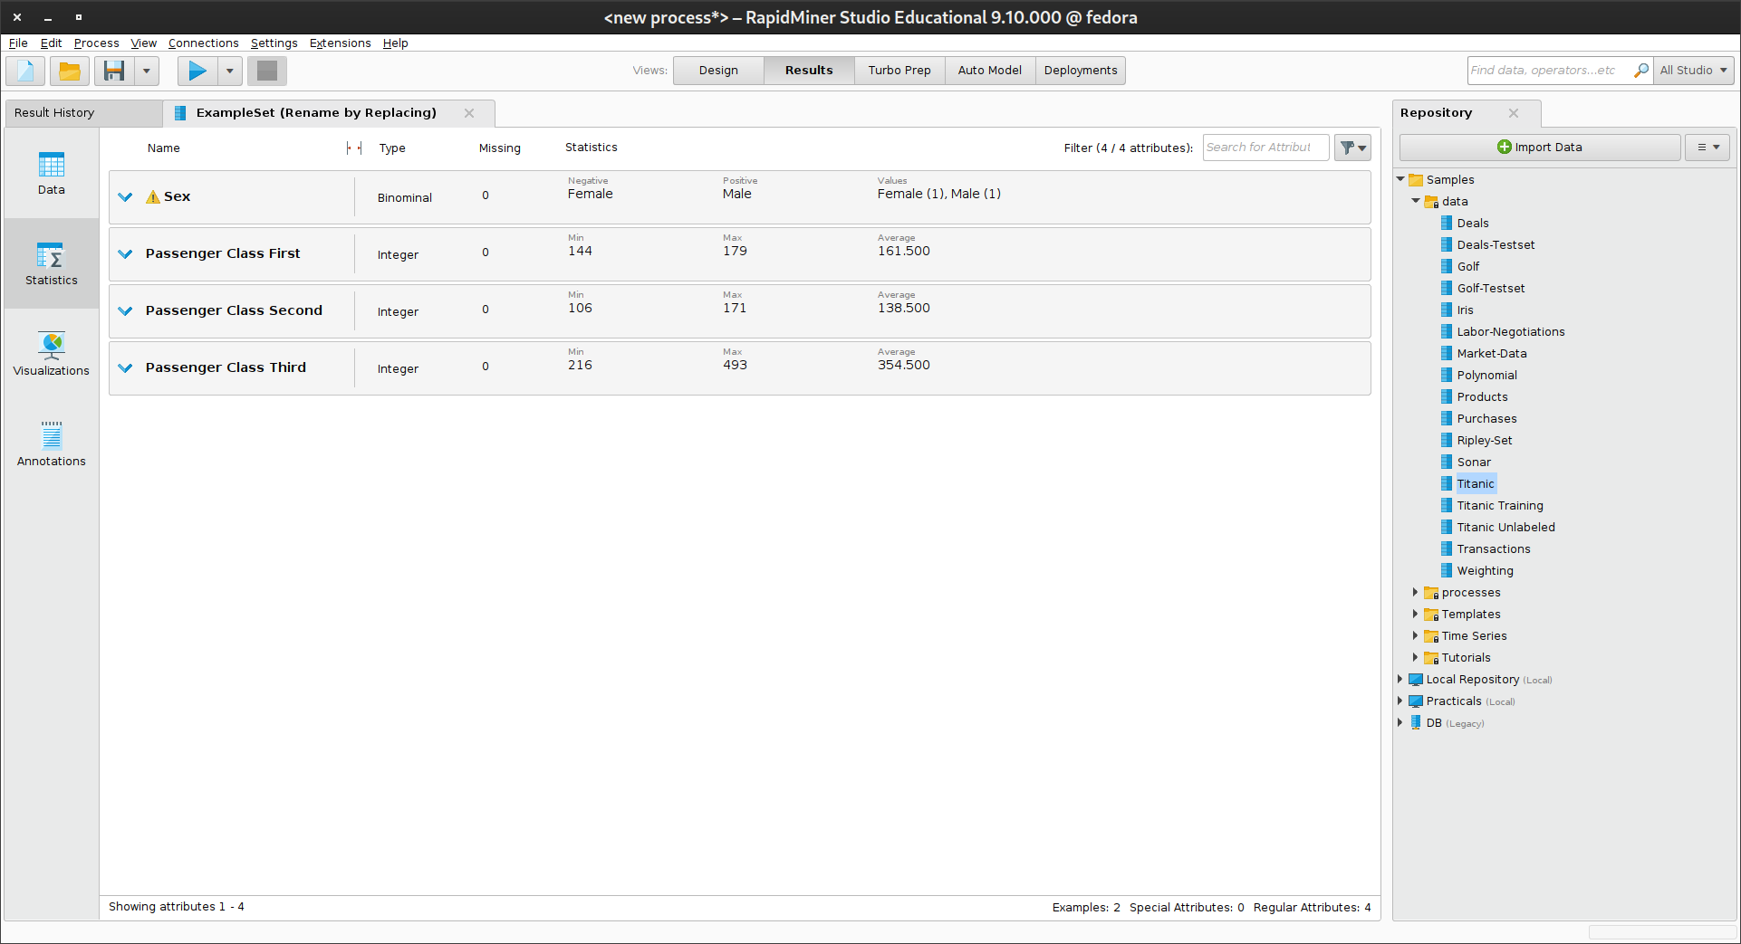
Visualization
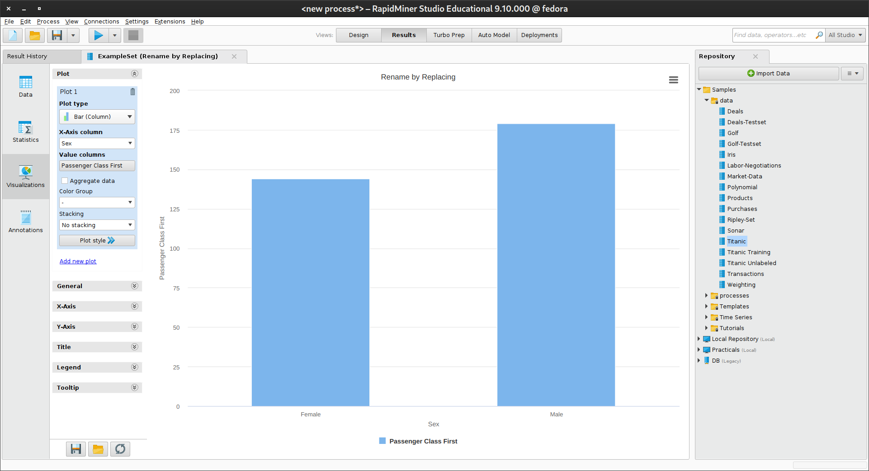

Interpretation
Date –
Activity 12 : Using Macros

Data sets used : Titanic

Steps:
Drag the Titanic data into the process.
Search for the operator Set Macro and add it to the process.
Connect Set Macro with Retrieve Titanic.
Click on Set Macro and make the following changes in its Parameters:
Set macro to fraction.
Set value to 0.5 .
Add the operator Extract Macro to the process and connect it.
In its Parameters, set macro to size.
Also set macro type to number_of_examples.
Search for the operator Generate Macro and drag it into the process.
Connect it.
In its Parameters, click on function descriptions.
Add a new entry with new size as macro name and round(eval(%{size})*eval(% {fraction})) as function expression.
Drag the operator Sample into the process and connect it.
Set the parameter sample size to %{new size} .
Connect the output of Sample to the result port on the right.
Run the process.
Statistics
Visualization
Interpretation
Date – X-X-2021
Activity 13 : Looping

Data sets used : Titanic

Steps:

Statistics
Visualization
Interpretation
Date – 16-09-2021
Activity 8 : Data Preprocessing

Data sets used : Titanic

Steps:

Statistics
Visualization
Interpretation
Date – 16-09-2021
Activity 8 : Data Preprocessing

Data sets used : Titanic

Steps:

Statistics
Visualization
Interpretation
Date – 16-09-2021
Activity 8 : Data Preprocessing

Data sets used : Titanic

Steps:

Statistics
Visualization
Interpretation

